Sri Lanka Institute of Information Technology



# Lab Submission Lab sheet 08

**IT24102521**

**Kotegoda S D**

**Probability and Statistics - IT2120**

B.Sc. (Hons) in Information Technology

**Exercise**

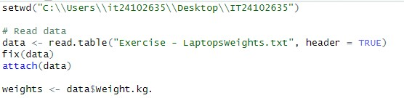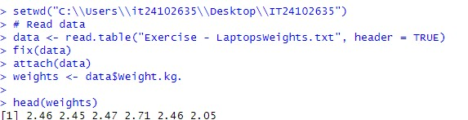

01)

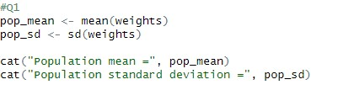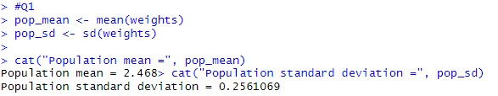

02)

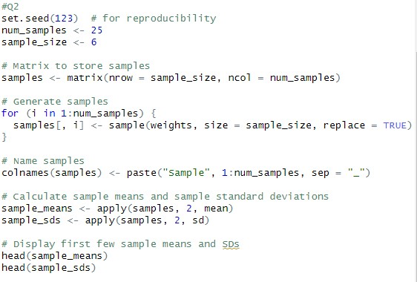

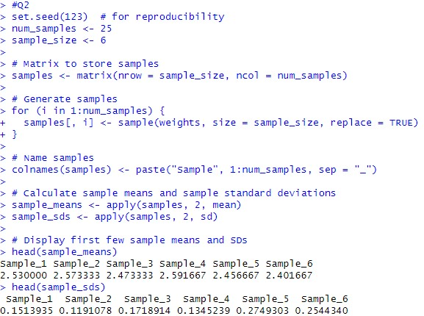

03)

